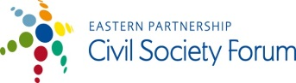 | 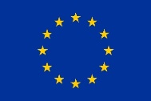 | 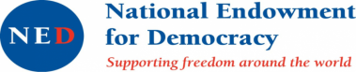 | 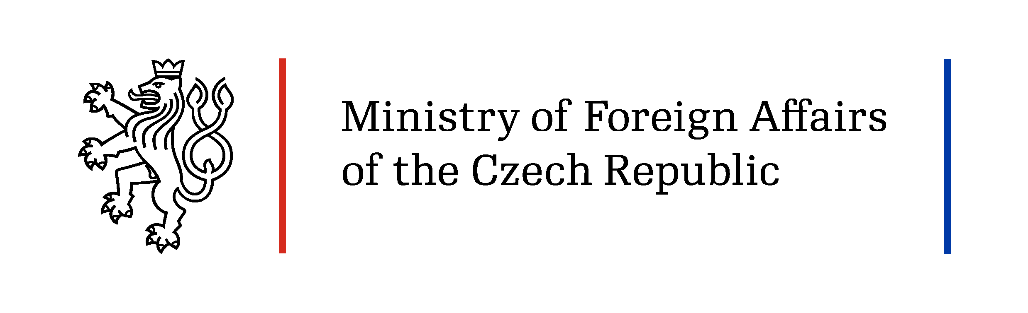
  Asociaţia Micului Business din Moldova |  | 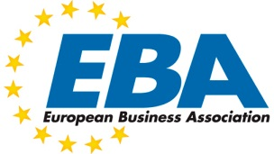 | 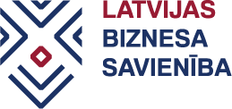

SMEs come together to seek ideas for economic development

This year SME organisations and business associations from Moldova, Georgia, Ukraine and Latvia will work together to define best ways to support the development of SMEs, finding the solutions for faster economic growth in a period of economic turmoil.

Moldova, Georgia and Ukraine are three Eastern Partnership (EaP) countries currently on the way to deeper European integration as witnessed by signed Association agreements and the Deep and Comprehensive Free Trade Areas (DCFTA) established within. To fully benefit from the DCFTA, these countries must undertake comprehensive reforms for liberalisation of the economy, facilitating more sustainable business solutions and improving business climate inside the country.

At the same time Latvia as a country coming from a similar background as Moldova, Ukraine and Georgia is an effective example not only how to foster economic reforms but also more recently on how to overcome major economic crisis by putting into place sound economic policy and innovative solutions that support business development in a period of limited financial resources.

Latvia has taken several steps that have helped SMEs to become the driving force in economic rejuvenation of the country. To define which ones of those ideas could be adopted in Moldova, Ukraine and Georgia and are implementable with limited resources available, that is in the core of the project.

To achieve it, the project partners will implement a set of activities:
- Study visit to Latvia meeting organisations responsible for creating SME environment in Latvia – Ministry of Economy, Ministry of Environmental Protection and Regional Development, state owned development finance institution “Altum”, municipality - Jūrmala City council, SME organisations like Business Union of Latvia, Women in business “Līdere” and other. (June 6 – 9, 2016)
- Country impact assessment reports evaluating the state of play for SMEs in Moldova, Georgia, Ukraine
- Round table discussion in Moldova on recommendations for necessary changes to the SMEs policies in Moldova, Georgia, Ukraine (October, 2016)
- Final Impact assessment report with recommendations for improvements based on the experience of Latvia
- Presentation of the lessons learned to respective governments

The project “Small Business Act for Europe and Deep and Comprehensive Free Trade Areas - Roadmap for Economic Development of Moldova, Georgia and Ukraine using experience of Latvia overcoming economic crisis” is supported by Eastern Partnership Civil Society Forum Re-granting Scheme.

Through its Re-granting Scheme, the Eastern Partnership Civil Society Forum (EaP CSF) supports projects of EaP CSF members with a regional dimension that will contribute to achieving the mission and objectives of the Eastern Partnership Civil Society Forum. The donors of the re-granting scheme are the European Union, National Endowment for Democracy and Czech Ministry of Foreign Affairs. The overall amount for the 2016 call for proposals is 307.500 EUR. Grants are available for CSOs from the Eastern Partnership and EU countries. Key areas of support are democracy and human rights, economic integration, environment and energy, contacts between people, social and labour policies.

The project is implemented by
- Small Business Association of Moldova in co-operation with
- Georgian association “Women in Business”,
- European Business Association (Ukraine),
- Business Union of Latvia.

This publication has been produced with the assistance of the European Union. The contents of this publication are the sole responsibility of <name of the author/ contractor/implementing partner/international organisation> and can in no way be taken to reflect the views of the European Union.

