
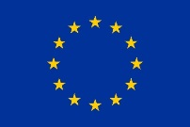
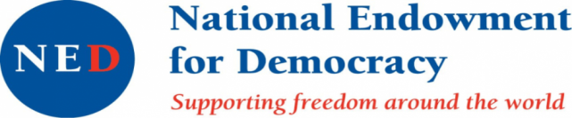
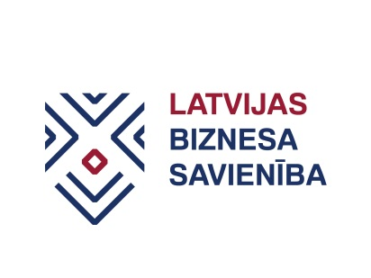


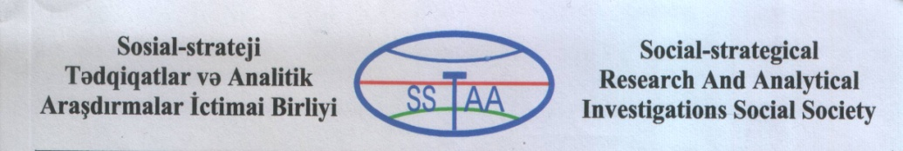

Latvia’s experience entering EU market might serve as lighthouse beacon to Eastern Partnership countries

During visit to Tbilisi and Baku, representatives of Business Union of Latvia emphasised that to be successful in export it is not enough to sign agreements between governments. Enterprises themselves should be proactive and prepare for serious battle with EU enterprises that might resist to new competitors in already saturated EU market. No less important is practical support provided by governments to SMEs in their exporting efforts.

During visit two seminars in Tbilisi and Baku for members of SME organisations and one round table discussion in Tbilisi with participation of representatives from partner countries, Georgian government and business organisations were held.

Closing round table discussion in Tbilisi Kakha Gogolashvili, representative of EaP CSF steering committee concluded: “Georgia has stepped deep in to the sea when the shore is no longer seen. Experience of Latvia might serve as a beacon of the lighthouse showing one direction that we could choose to go.”

Addressing participants of the seminar in Baku, İlqar Ehtiram Huseynlı, President of Social Strategic Researches and Analytical İnvestigations Public Union noted, that joining DCFTA might help in Azerbaijan’s aspirations for export diversification, diminishing dependence on oil product export in economy. Also – standards that would have to be introduced, could help making food safer not only for export but also for locals.

During seminars in Tbilisi and Baku, chairman of the Business Union of Latvia Eduards Filippovs introduced to experience of Latvian enterprises entering EU market sharing not only good examples but also failures and showed tactics used by EU enterprises fighting against new competitors in the market. He also noted, that to facilitate export, essential role should be played by government and its practical support to SMEs. Special interest both in Georgia and Azerbaijan was raised by the “Export credit guarantee” programme administered by Latvian Development Finance institution “Altum”. It is a programme that was considered to be a good example on how it is possible to diminish risks faced by exporters.

Part of practical seminars was devoted to identifying potential export products of Georgia and Azerbaijan. During workshops led by advisor to Business Union of Latvia Gunta Misāne, best strategies for entering EU market with these products were developed. These ideas will be presented in the handbook that will be elaborated during project.

Next workshop is scheduled to take place in August in Chisinau.

The project “Benefitting from EU open market: SMEs practical guide to DCFTA learning from experience of Latvia” is implemented by:
- Georgian association “Women in Business”, in co-operation with
- Business Union of Latvia,
- Social Strategic Researches and Analytical Investigations Public Union (Azerbaijan) and
- NGO BIOS (Moldova).

More about project

The project benefits from the support through the EaP CSF Re-granting Scheme. Within its Re-granting Scheme, the Eastern Partnership Civil Society Forum (EaP CSF) supports projects of the EaP CSF members with a regional dimension that contribute to achieving the mission and objectives of the Forum. The donors of the Re-granting Scheme are the European Union and National Endowment for Democracy.

The overall amount for the 2017 call for proposals is 290.000 EUR. Grants are available for CSOs from the Eastern Partnership and EU countries. Key areas of support are democracy and human rights, economic integration, environment and energy, contacts between people, social and labour policies.

This material has been produced with the assistance of the European Union. The contents of this publication are the sole responsibility of project implementing partners and can in no way be taken to reflect the views of the European Union.

