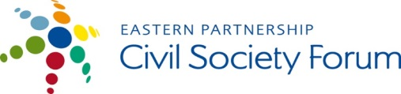
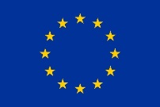
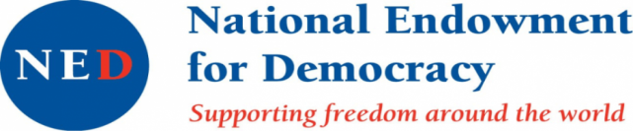
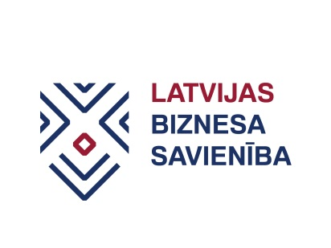
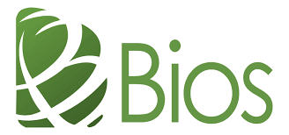
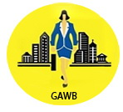
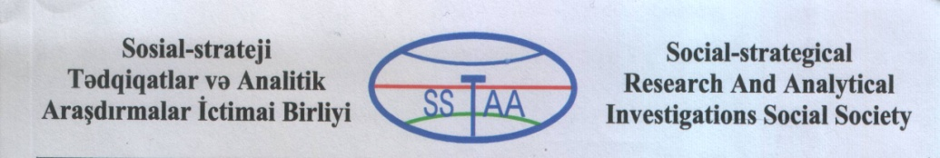

SMEs working together in finding better ways to benefit from EU open market

During joint project, SME organisations from Georgia, Azerbaijan and Moldova will learn about best practices and failures experienced by Latvian enterprises entering EU open market and share ideas, approaches to become better equipped for the export activities.

Moldova, Georgia and Azerbaijan are Eastern Partnership (EaP) countries currently on the way to deeper European integration as witnessed by signed Association agreements and the Deep and Comprehensive Free Trade Areas (DCFTA) established within. To fully benefit from the DCFTA, SMEs in these countries must prepare for rules of the game when entering EU market.

Project partner countries differ in their approaches. Among other Georgia has made significant progress in institutional framework environment for SME policy and creating support structures helping businesses comply with DCFTA requirements. At the same time Azerbaijan and Moldova also have their best practices to share and mistakes to learn from. Sharing these experiences is an effective way to learn from each other. Latvia has undergone similar process in late nineties and still there are cases when SMEs struggle to benefit from EU open market. Their experience both – good and bad – can be useful learning tool for SMEs in EaP countries.

To share experiences, the project partners will implement a set of activities:
- Workshops in Georgia, Azerbaijan and Moldova, sharing best practices and failures experienced by Latvian enterprises entering EU market; and support tools created by government to support SMEs (June –August, 2017);
- Round table discussion in Georgia with participation of all project partners sharing different approaches of partner countries to DCFTA adaptation (July 2017);
- Writing and distributing a handbook for SMEs „How to benefit from DCFTA?” (August-September, 2017);
- Rising public awareness on DCFTA.

The project “Benefitting from EU open market: SMEs practical guide to DCFTA learning from experience of Latvia” is implemented by:
- Georgian association “Women in Business”, in co-operation with
- Business Union of Latvia,
- Social Strategic Researches and Analytical Investigations Public Union (Azerbaijan) and
- NGO BIOS (Moldova).

The project benefits from the support through the EaP CSF Re-granting Scheme. Within its Re-granting Scheme, the Eastern Partnership Civil Society Forum (EaP CSF) supports projects of the EaP CSF members with a regional dimension that contribute to achieving the mission and objectives of the Forum. The donors of the Re-granting Scheme are the European Union and National Endowment for Democracy.

The overall amount for the 2017 call for proposals is 290.000 EUR. Grants are available for CSOs from the Eastern Partnership and EU countries. Key areas of support are democracy and human rights, economic integration, environment and energy, contacts between people, social and labour policies.

This material has been produced with the assistance of the European Union. The contents of this publication are the sole responsibility of project implementing partners and can in no way be taken to reflect the views of the European Union.

