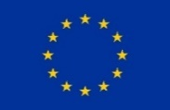
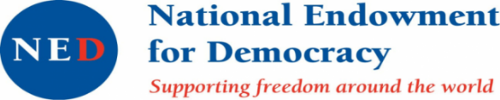

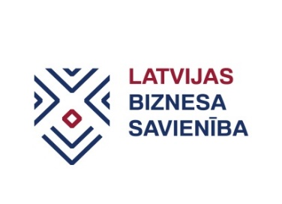

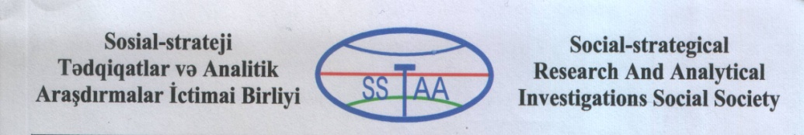


Looking for best strategiesto facilitate SME development in the regions of Azerbaijan, Georgia and Ukraine

Partners from Azerbaijan, Georgia, Ukraine and Latvia will come together to seek best strategies and measures targeted towards SME development in regions. Some of the measures will be tested during pilot events and best ideas will be shared in the recommendation paper developed by partners.

Georgia and Ukraine are Eastern Partnership (EaP) countries and signed Association Agreements (AA) and the Deep and Comprehensive Free Trade Areas (DCFTA). Although Azerbaijan haven’t signed these agreements yet, it has put steps on the way to deeper European integration. It is evident that SMEs and business organisations in the capital cities of all partner countries are more aware about the AA and the DCFTA and its conditions. These abilities are less evident among SMEs and business organisations in regions of EaP countries.

There are many initiatives known and practised in all partner countries, other EaP and EU countries that are targeted to strengthening SMEs and their organisations, especially regional SMEs. Among them are informative events, promotional events, internet-based solutions, long term initiatives involving local municipalities, structures created for better involvement of SMEs in local decision making etc. This project will aim at sharing these initiatives, ideas and identifying ones that could work also in EaP partner countries. The project also aims at testing these ideas in practice by organising regional SME events in partner countries from EaP countries. Moreover, the project focuses on how to tempt governments of EaP countries to adopt and implement of SME strategies that will specially be beneficial for SMEs functioning in the regions of countries. Inspiration will be also drawn from experience of Latvian partner and a major yearly EU business event – European Enterprise Promotion Awards that celebrates new and effective ideas that promote development of SMEs.

To share experiences, the project partners will implement a set of activities:
- Study visit / workshop in Qazakh – a northern region of Azerbaijan (June 2019);
- Pilot events in Azerbaijan, Georgia and Ukraine (July–August 2019);
- Recommendations for regional events, regional SME support strategies (August-September 2019);
- Raising public awareness about need for special regional SME support strategies.

The project “Development of SME strategies and its impact on regional SMEs” is implemented by:
- Social Strategic Researches and Analytical Investigations Public Union (Azerbaijan) in co-operation with
- Georgian association “Women in Business”,
- Center for cross-border cooperation(Ukraine)and
- Business Union of Latvia.

The project benefits from support through the EaP Civil Society Forum Re-granting Scheme (FSTP) and is funded by the European Union as part of its support to civil society in the region. Within its Re-granting Scheme, the Eastern Partnership Civil Society Forum (EaP CSF) supports projects of its members that contribute to achieving the mission and objectives of the Forum.

Grants are available for CSOs from the Eastern Partnership and EU countries. Key areas of support are democracy and human rights, economic integration, environment and energy, contacts between people, social and labour policies.

This material has been produced with the assistance of the European Union. The contents of this publication are the sole responsibility of project implementing partners and do not necessarily reflect the views of the European Union.

